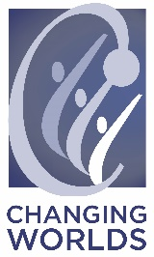
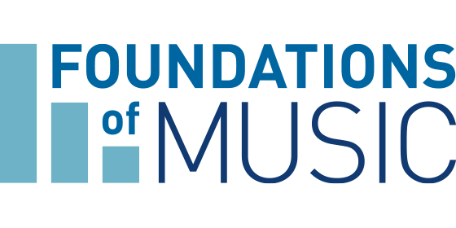
FOR IMMEDIATE RELEASE
August 6, 2019

Contact:
Genna Pirrong: (312) 729-3668
genevieve.pirrong@fleishman.com

FOUNDATIONS OF MUSIC AND CHANGING WORLDS JOIN FORCES TO DRIVE GREATER IMPACT FOR ARTS EDUCATION
CHICAGO – Foundations of Music, a local nonprofit that provides foundational music education to under-resourced Chicago communities, and Changing Worlds, a local nonprofit that provides interdisciplinary art education programs to youth, announced today that the two will join forces to expand their services to offer greater efficacy in music and arts education for children in the Chicago area. Effective this summer, Foundations of Music became a program of Changing Worlds.
Combining Changing Worlds and Foundations of Music brings a wealth of professional experience and stronger resources to the Chicago community. Together, the two organizations will take what they have built independently to create richer, deeper and more accessible programs for a broader audience. Changing Worlds will introduce elements of visual arts, dance, theatre and writing to its newly acquired music programs, while Foundations of Music's expertise in music will influence and expand its already interdisciplinary programs.
“We’re thrilled to welcome Foundations of Music, their teaching artists, programs, board members and administrative staff into our family, said Alicia Vega, Executive Director of Changing Worlds. “Their impact on Chicago’s children and youth with music is remarkable and together we can significantly expand our reach across the city to support our collective missions of empowering Chicago children who are most in need.”
For more than 30 years, Foundations of Music has provided music programming to young people across the Chicagoland area. The classes the organization provides, which include general music, songwriting/production, and live performance programs, are all focused on providing children with a music education that they can take with them for years to come.
“We have been familiar with Changing Worlds for quite some time and are impressed with how they have introduced students to unique cultural perspectives through artistic mediums in the classroom,” said Laurie Miller, Board President of Foundations of Music. “We’re excited to have found a partner that shares our passion for arts education and understands that music is an essential element to a quality education, enhancing cross-cultural understanding and the overall human experience.”
Currently Changing Worlds provides visual, literacy and performing arts programs to nearly 2,000 students in in 25 schools within 20 communities across the Chicagoland area. Together, Changing Worlds and Foundations of Music will bring general music, as well as song writing & music production programming to an additional 1,000 students, in 15 more schools and in 10 new communities because of its recently announced partnership.
About Foundations of Music
Foundations of Music is the leader in providing fundamental music education during the school day. For 30 years, the nonprofit has used music to strengthen Chicago communities by partnering with Chicago Public Schools in the most economically disadvantaged neighborhoods. The organization works with professional musicians to develop and implement lesson plans that are inspired by a curriculum map which meets national arts learning standards. Programs include General Music Class, Songwriting/Production Class and other performance opportunities.
For more information, please visit www.foundationsofmusic.org.
About Changing Worlds
Changing Worlds is a 23-year-old nonprofit organization that exists to foster inclusive communities through oral history, writing and arts programs that improve student learning, affirm identity and enhance cross cultural understanding. Changing Worlds works toward its mission through interconnected program areas that include in-school and after school partnerships programs for students from kindergarten to 12th grade as well as community outreach initiatives such as traveling exhibits, community based collaborative partnerships and special events for all ages.

For more information, please visit https://www.changingworlds.org/.
###

